SOFTWARE REQUIREMENT ENGINEERING

Assignment on Project management tool

Faculty - Abhijit Bhowmik

SECTION - B

|  |  |
| --- | --- |
| **Name** | **id** |
| **RAGIB , MD JUBAET HASSAN** | **17-34060-1** |
| **HAQUE , S M RAHID** | **17-33107-1** |
| **ahmed , sharif** | **17-33173-1** |
| **m.k. akram hossain** | **17-33200-1** |

**Assignment on Project Management Tool**

The tool used for project management is Bitrix24 and our group members are all created their accounts and created a dummy project and assign tasks to the members after creating.

1. **Screenshots of all the group members during opening Bitrix24 account:**

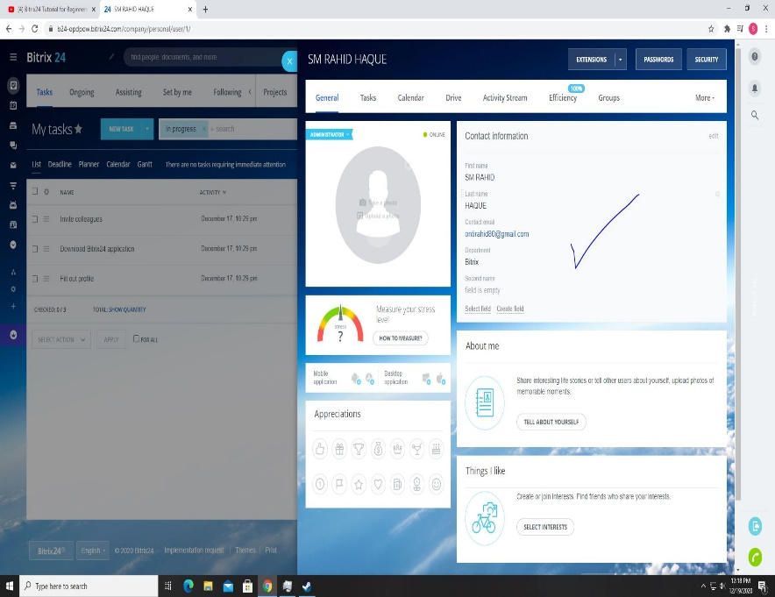**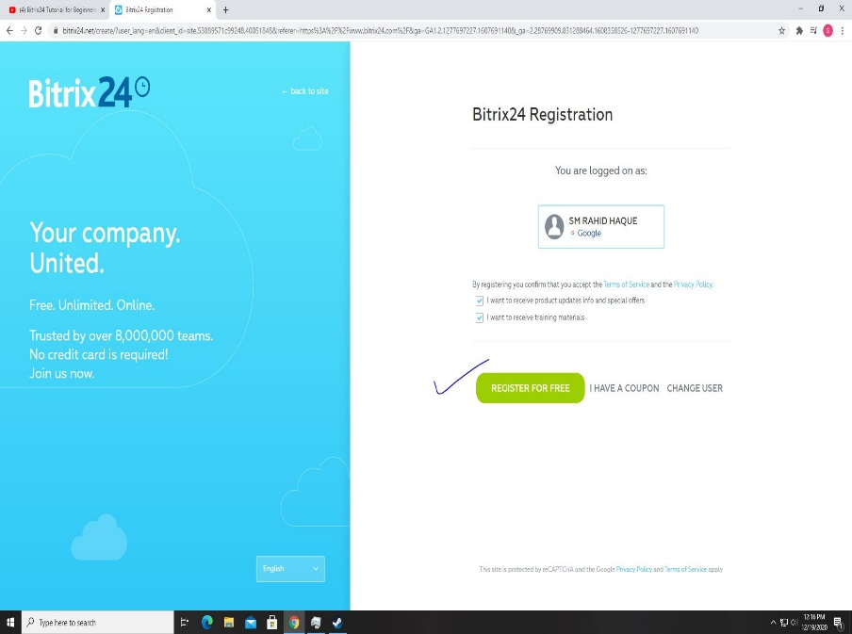Member 1: S M RAHID HAQUE**

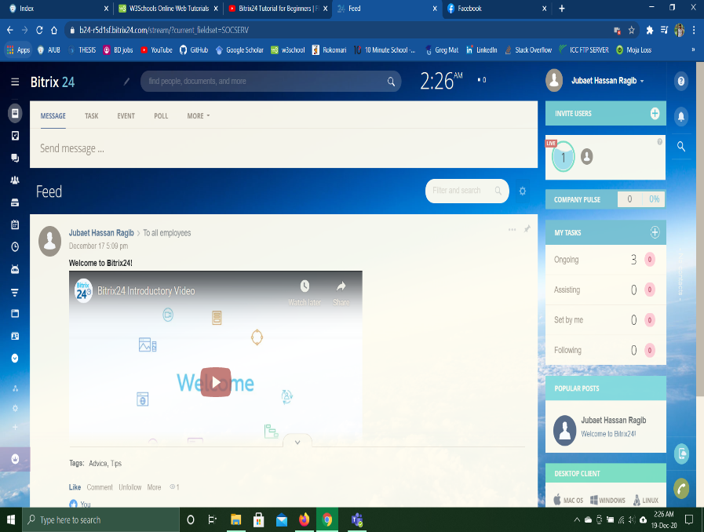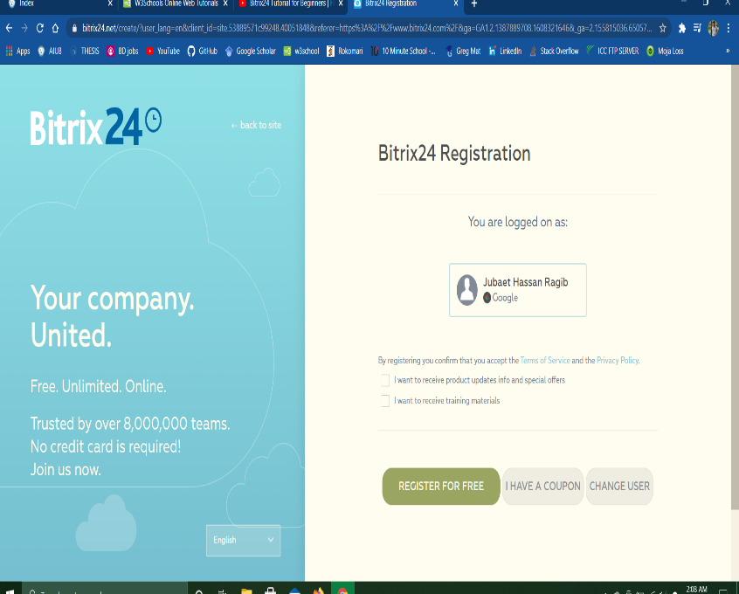**Member 2: MD JUBAET HASSAN RAGIB**

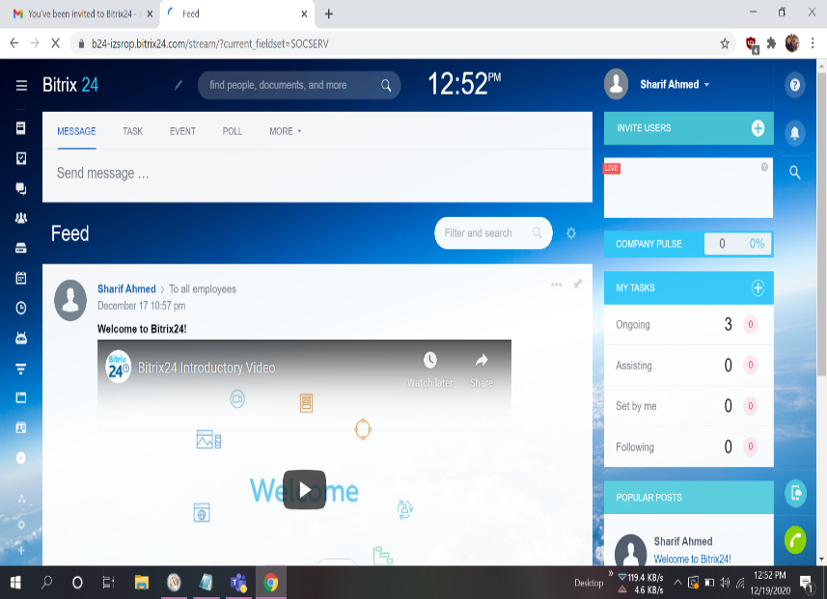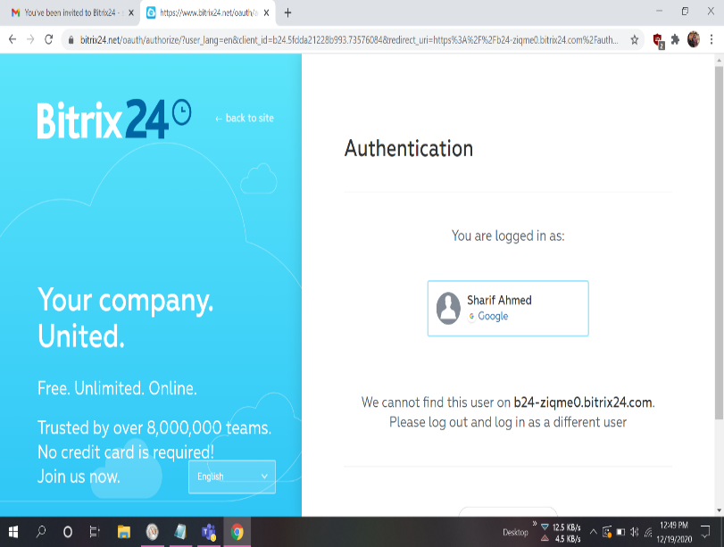**Member 3: SHARIF AHMED**

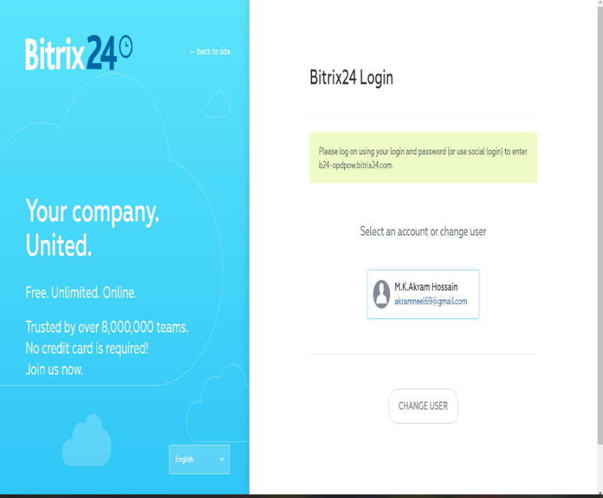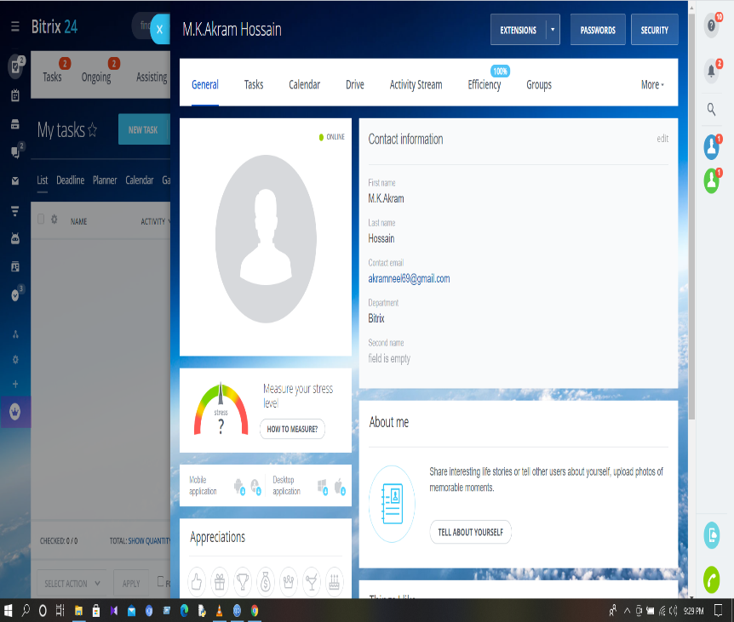**Member 4: M.K. AKRAM HOSSAIN**

1. **Benefit of creating Project Management Tool and benefit of using Bitrix24:**

Using project management tool has many advantages, few of them are mentioned below:

1. It is easier to synch everything in one place and it is quite accurate all the time.
2. It is very easy to track any requirements from the stakeholders using the project management tool.
3. Using project management is less time-consuming approach.
4. Project Management tool can easily identify any duplicate or missing requirements in the project.
5. Group members can work together in the project management tool working from home very easily in this COVID-19 pandemic.
6. Project Management tool can be used for storing any attributes in our project in one place and can be accessed easily.

The tool that we used for the assignment is Bitrix24 and some of the benefit of using this particular tool is given below:

1. Easily accessible for all the group members in our team for creating a dummy project.
2. We can work here without doing any manual work which is beneficial as we are apart from each other.
3. Can easily set the deadline of all the group members by the owner.
4. Gannt chart can be seen to view the schedule of the tasks given to team members.
5. Can add or extend any users

**P.T.O**

1. **Screenshots of Dummy Project Practice in Bitrix24:**

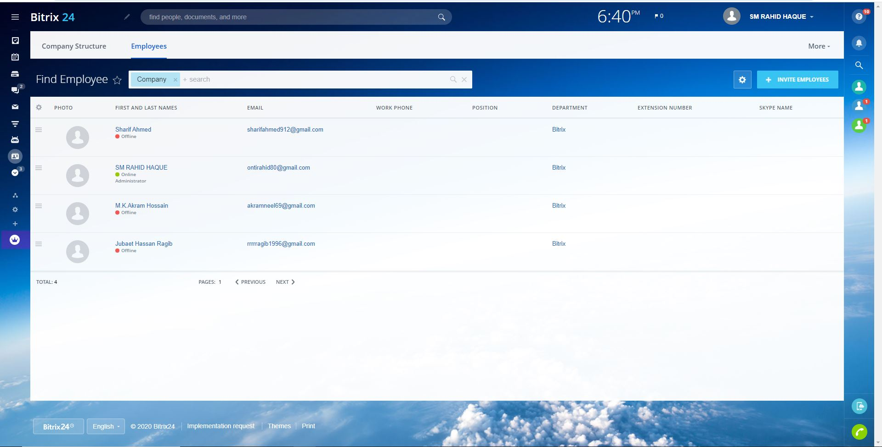**List of Team Members in the project:**

**Creating the Dummy Project in Bitrix24:**

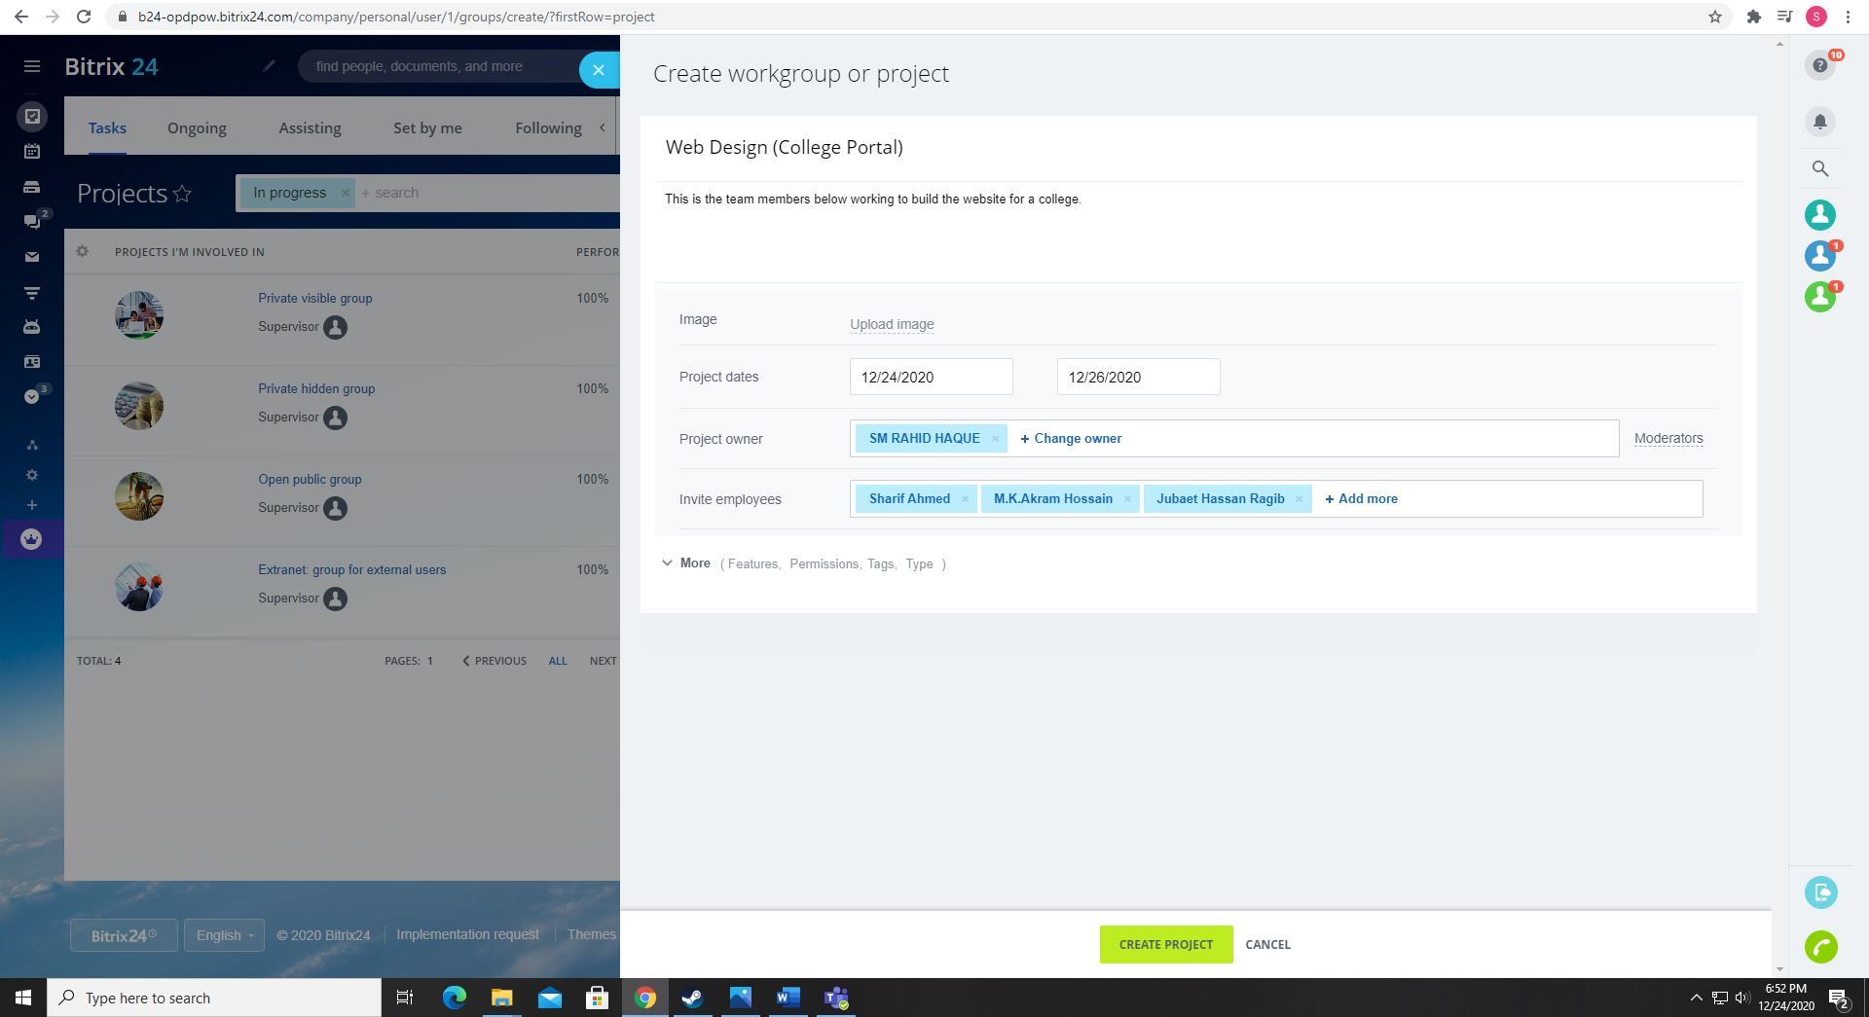

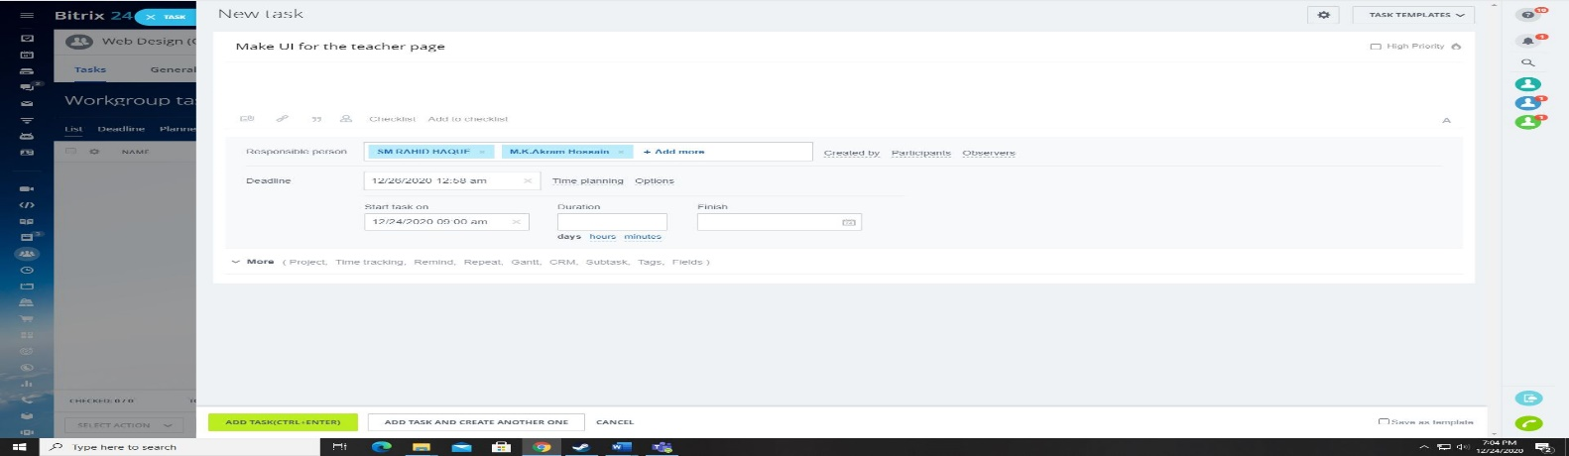**Assigning Task to the group members in Bitrix24:**

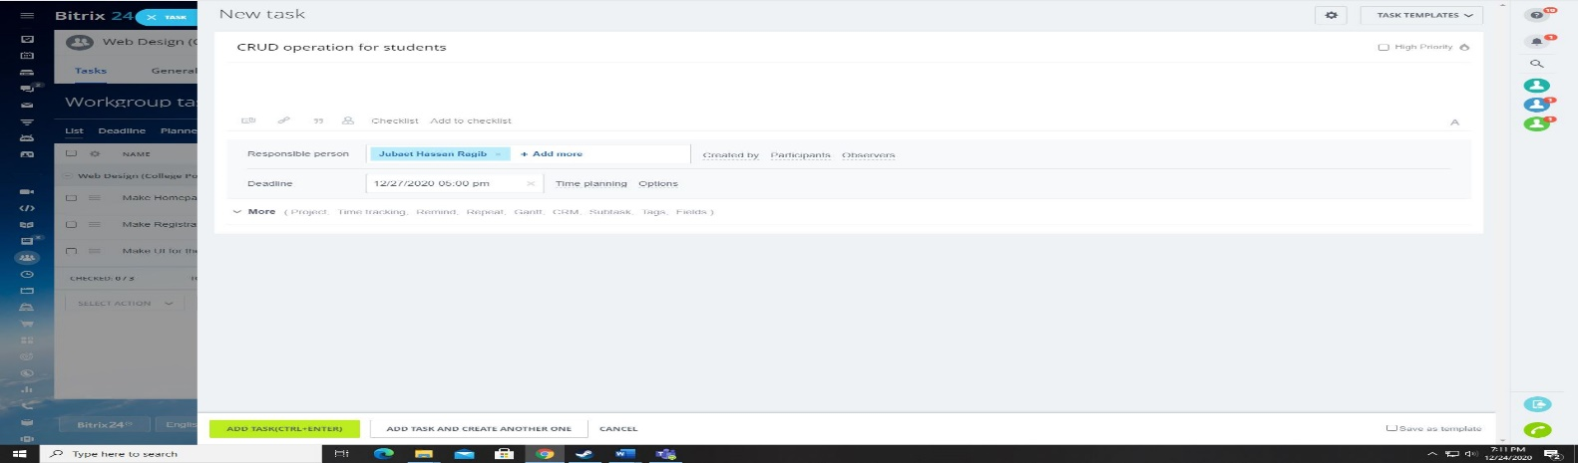

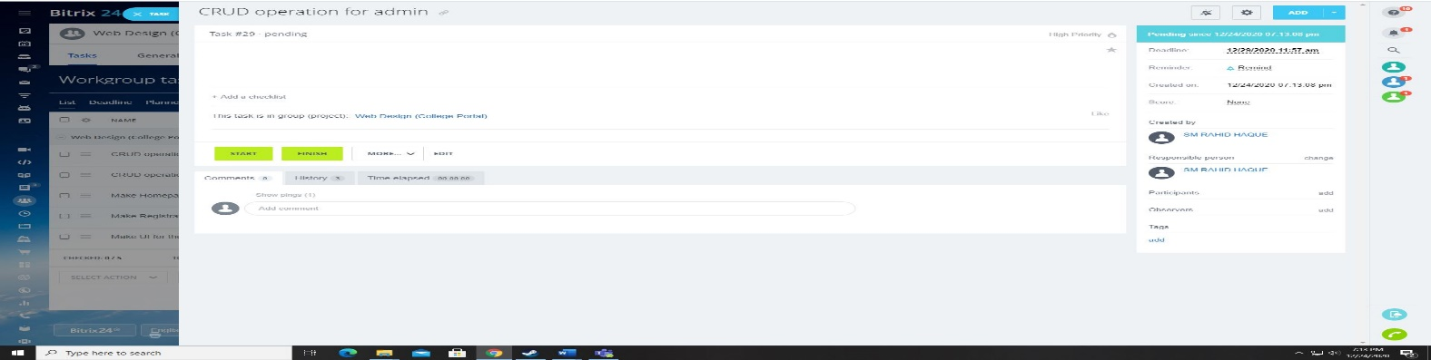

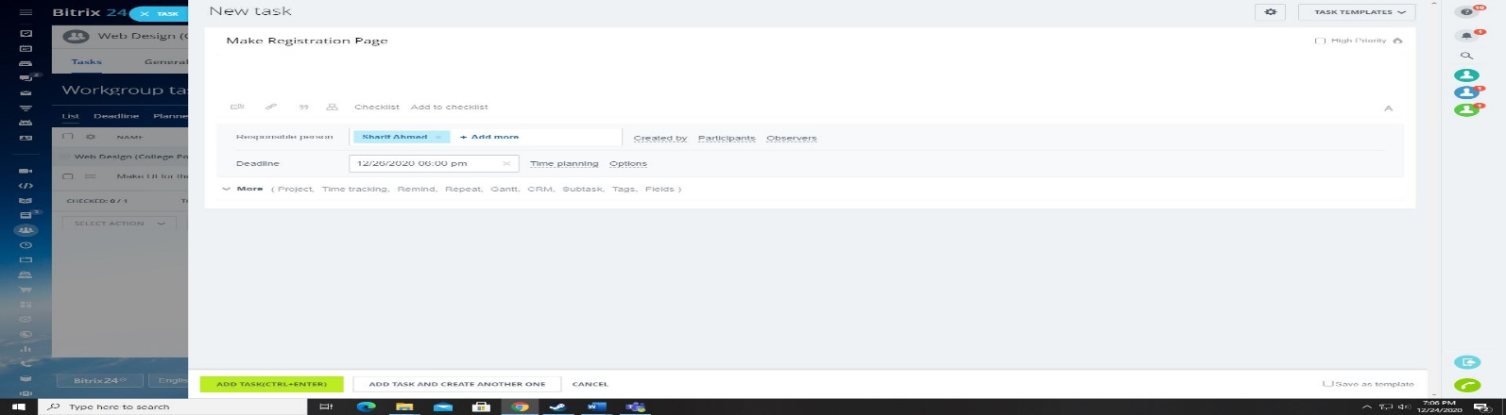

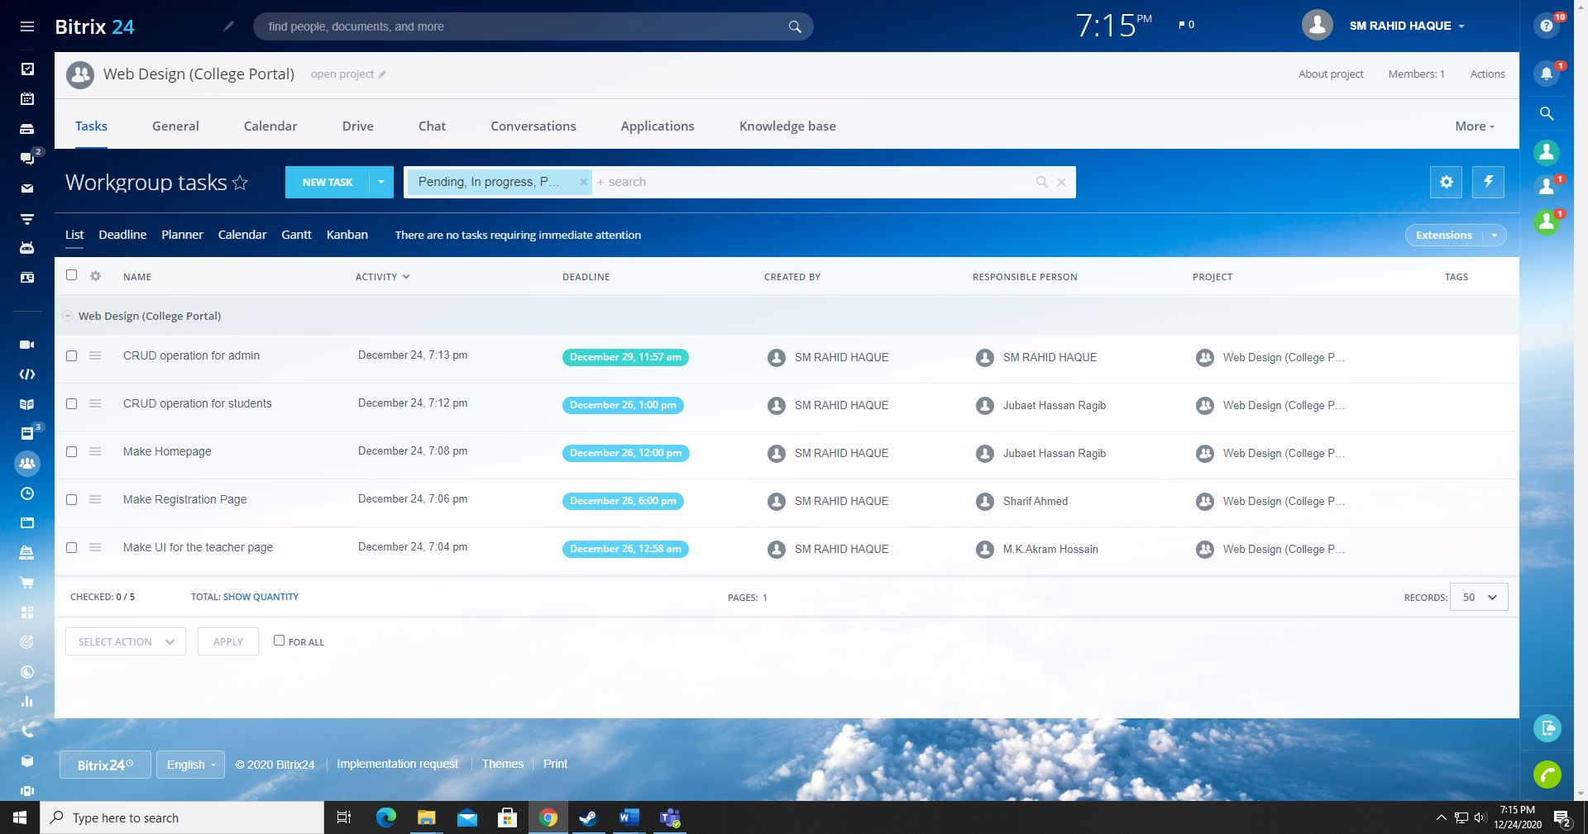**List of the Assigned Tasks in the dummy project:**

**Ability to see the created tasks deadlines in Bitrix24:**

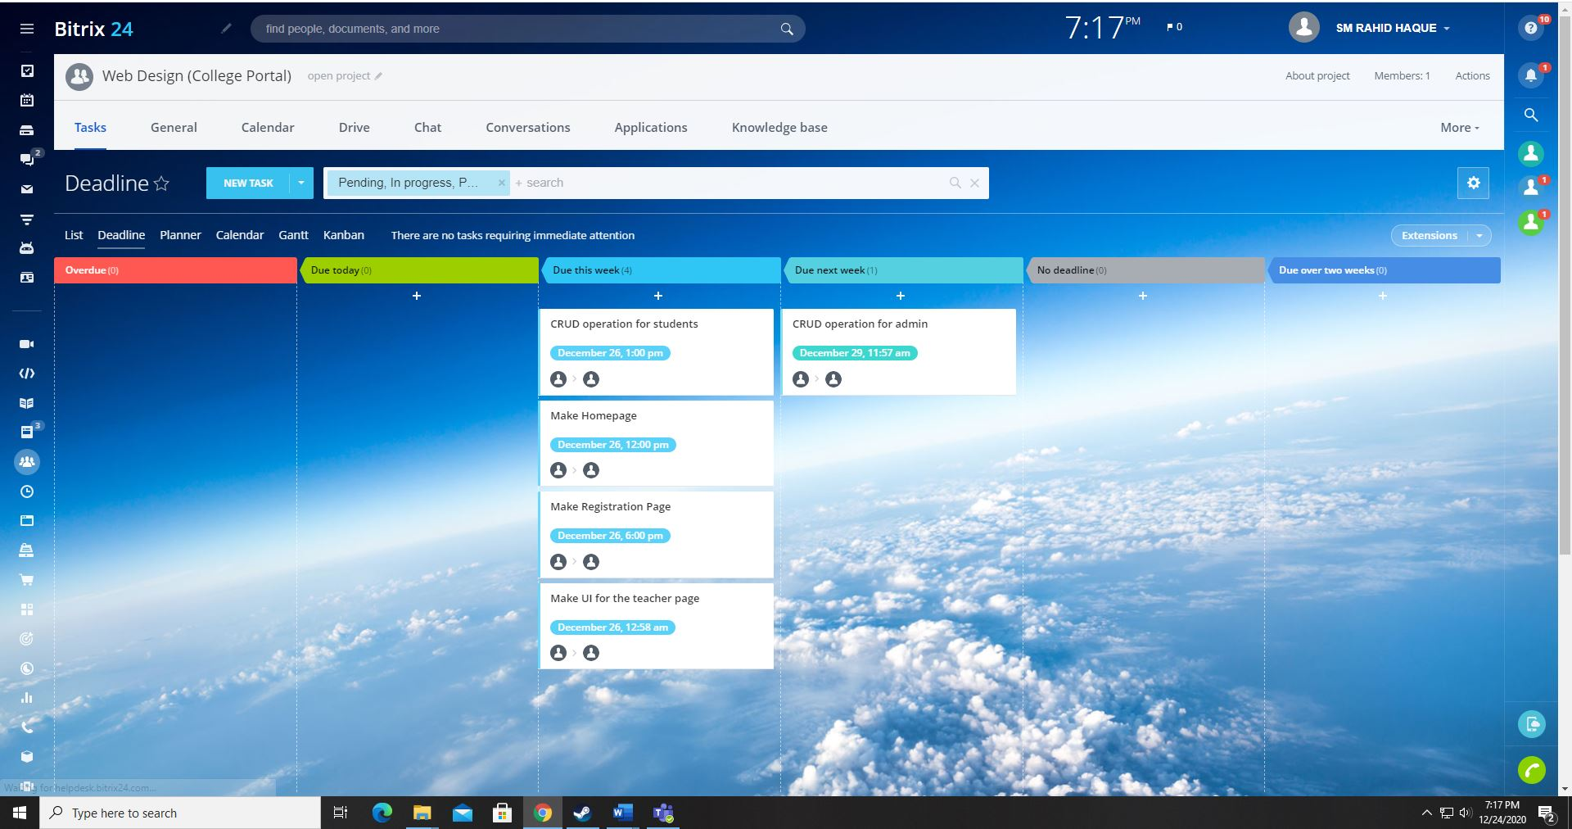

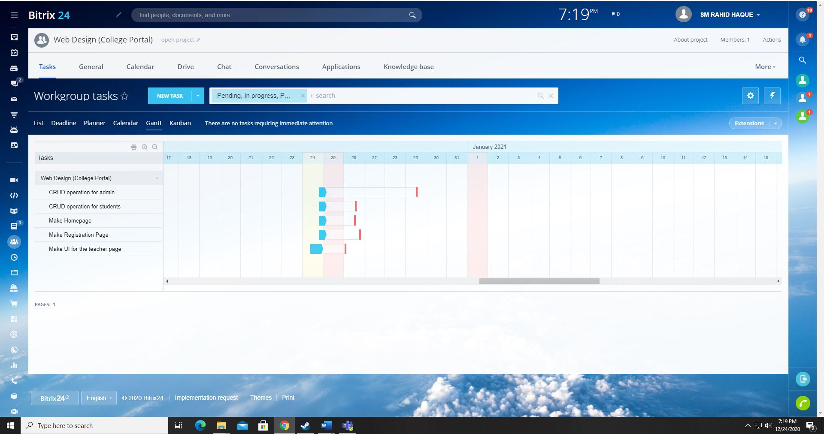**Gantt Chart of the project:**